**UTreatment**

**Verification test report (part 2)**

**Document reference number:** VeTR2

**Scope:** This document contains the test result from the second out of four verification reports of the UTreatment system.

**Author:** Emma Rothmann, Katrine Stephansen, Louise Leonhard & Saaluja Sriharan

**References:** VeTP2

**Revision history:**

| **Revision** | **Revised by** | **Revision date** | **Description of changes** |
| --- | --- | --- | --- |
| 1.0 | Katrine Stephansen and Louise Leonhard | 29.04.2022 | First version |
|  |  |  |  |
|  |  |  |  |

## 

## 

## Verification test result: Oprettelse af ny patient

| **Requirement ID** | **Description of requirement** | **Status** |
| --- | --- | --- |
| FR5 | UTreatment skal indeholde en brugergrænseflade til  indtastning af patientinformationer. | ✔ |
| FR6 | UTreatment skal inkludere forskellige parametre som  beslutningsgrundlag for outputtet i form af en anbefa-  ling til stimulationsstrategi. | ✔ |
| FR17 | UTreatment skal kunne visualisere en fejlmeddelelse ved manglende indtastning af patientinformation | X |

*Main approach*

*Step 1-8:*

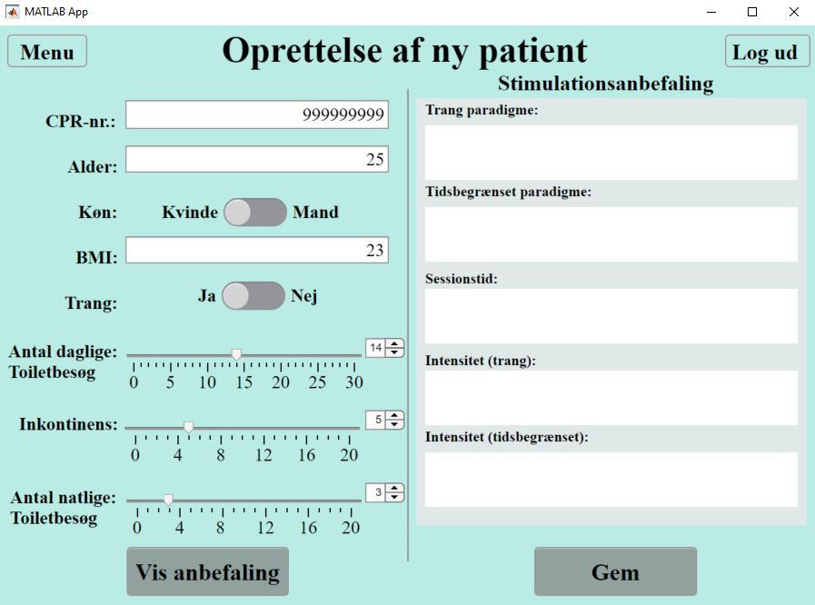

*Step 9:*

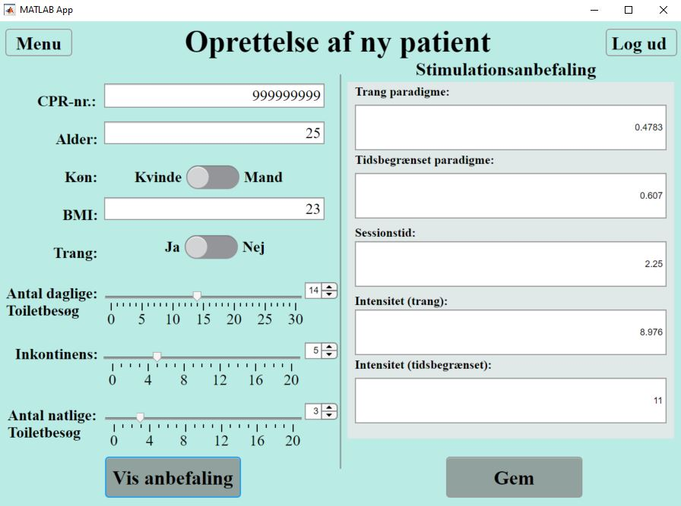

*Alternative approach (1)*

*Step 1-9:*

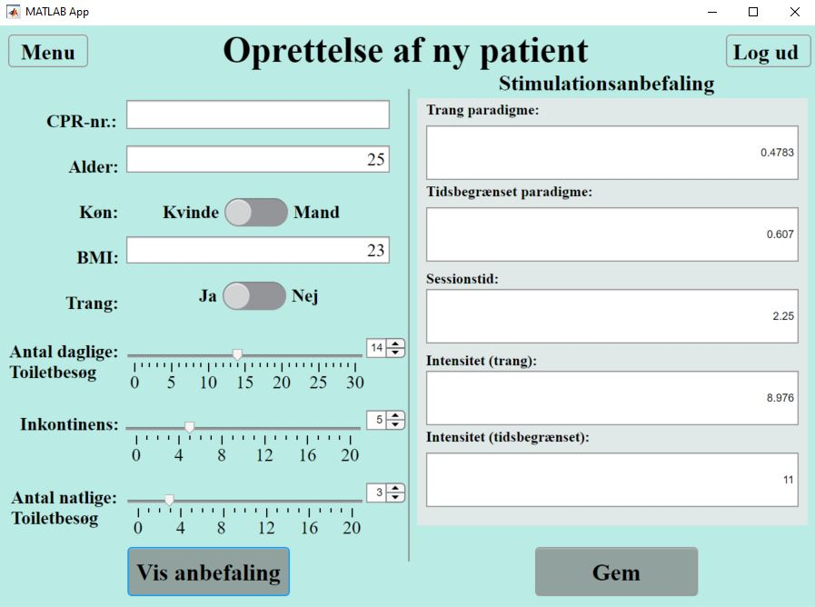

The results of the tests of the following alternative approaches (2-8) are similar to the result of the test of the alternative approach (1). Pictures of these tests are therefore not included.